Z_HomeAssignment3.R
Pierre Klintefors
Fri Dec 07 13:54:38 2018
rm(list=ls(all=TRUE)) # clears the workspace
graphics.off() # clears graphics
#################
#Load Packages
##############
library(psych) # for describe
library(reshape2) # for melt function
library(ggplot2) # for ggplot
##
## Attaching package: 'ggplot2'
## The following objects are masked from 'package:psych':
##
## %+%, alpha
library(cAIC4) # for cAIC
## Loading required package: lme4
## Loading required package: Matrix
## Loading required package: stats4
library(r2glmm) # for r2beta
library(influence.ME)
##
## Attaching package: 'influence.ME'
## The following object is masked from 'package:stats':
##
## influence
library(lattice)
#######################
#set working directory
########################
setwd("~/PSYP13/Rwork")
######################
###Import dataset
######################
pain.data.time <- read.csv("https://raw.githubusercontent.com/kekecsz/PSYP13_Data_analysis_class-2018/master/home_sample_3.csv")
View(pain.data.time)
###################################################################
####Extract standardized beta coefficients from linear mixed models
###################################################################
stdCoef.merMod <- function(object) {
sdy <- sd(getME(object,"y"))
sdx <- apply(getME(object,"X"), 2, sd)
sc <- fixef(object)*sdx/sdy
se.fixef <- coef(summary(object))[,"Std. Error"]
se <- se.fixef*sdx/sdy
return(data.frame(stdcoef=sc, stdse=se))
}
###################################
###Descriptives and histograms
###################################
describe(pain.data.time)
## vars n mean sd median trimmed mad min max
## ID* 1 20 10.50 5.92 10.50 10.50 7.41 1.00 20.00
## pain1 2 20 5.41 1.71 5.11 5.35 1.18 1.54 8.92
## pain2 3 20 3.90 1.32 4.05 4.00 1.50 0.36 5.55
## pain3 4 20 3.41 0.90 3.51 3.49 0.96 1.16 4.57
## pain4 5 20 3.08 0.53 3.14 3.13 0.55 1.60 3.76
## sex* 6 20 1.55 0.51 2.00 1.56 0.00 1.00 2.00
## age 7 20 39.85 5.20 39.00 40.06 5.19 30.00 50.00
## STAI_trait 8 20 39.15 3.36 39.00 39.00 3.71 34.00 45.00
## pain_cat 9 20 30.00 5.46 28.50 29.81 6.67 22.00 39.00
## cortisol_serum 10 20 5.13 1.05 5.24 5.22 1.35 2.86 6.34
## cortisol_saliva 11 20 5.26 0.69 5.25 5.28 0.79 3.92 6.61
## mindfulness 12 20 2.89 0.95 3.07 2.93 1.03 1.10 4.20
## weight 13 20 72.66 13.21 72.97 72.07 11.57 50.16 102.02
## range skew kurtosis se
## ID* 19.00 0.00 -1.38 1.32
## pain1 7.38 0.23 0.04 0.38
## pain2 5.19 -0.75 0.23 0.29
## pain3 3.41 -0.69 -0.26 0.20
## pain4 2.15 -0.94 0.69 0.12
## sex* 1.00 -0.19 -2.06 0.11
## age 20.00 -0.21 -0.58 1.16
## STAI_trait 11.00 0.19 -1.19 0.75
## pain_cat 17.00 0.32 -1.33 1.22
## cortisol_serum 3.49 -0.49 -0.97 0.23
## cortisol_saliva 2.69 -0.21 -0.75 0.16
## mindfulness 3.10 -0.32 -1.09 0.21
## weight 51.85 0.36 -0.21 2.95
hist(pain.data.time$pain1)
hist(pain.data.time$pain2)
hist(pain.data.time$pain3)
hist(pain.data.time$pain4)
######################################
###Designate the repeated varibles
######################################
# designate which are the repeated varibales
repeated.variables = c("pain1", "pain2", "pain3", "pain4")
cor(pain.data.time[,repeated.variables])
## pain1 pain2 pain3 pain4
## pain1 1.0000000 0.8121490 0.8428394 0.5499557
## pain2 0.8121490 1.0000000 0.8981431 0.5356093
## pain3 0.8428394 0.8981431 1.0000000 0.7109364
## pain4 0.5499557 0.5356093 0.7109364 1.0000000
####################################
###Reshape dataset from wide to long
####################################
pain.data.long = melt(pain.data.time, measure.vars=repeated.variables,
variable.name = "day", value.name = "pain_rating")
pain.data.long = pain.data.long[order(pain.data.long[,"ID"]),]
View(pain.data.long)
pain.data.long$day <- as.numeric(pain.data.long$day)
######################################################
###Creating a mixed linear model with random intercept
######################################################
model.int <- lmer(pain_rating ~ sex + age + weight + STAI_trait + pain_cat + mindfulness + cortisol_serum
+ day + (1|ID), data = pain.data.long)
#####################################################
###Creating a model with random intercept and slope
#####################################################
model.slope <- lmer(pain_rating ~ sex + age + weight + STAI_trait + pain_cat + mindfulness + cortisol_serum
+ day + (day|ID), data = pain.data.long)
########################################################################
###Create a copy of dataset that can be used for predicting and plotting
########################################################################
pain.data.long.withpreds = pain.data.long
pain.data.long.withpreds$pred.int = predict(model.int)
pain.data.long.withpreds$pred.slope = predict(model.slope)
################################################
###Plot the two models with randomm intercept and slope
################################################
#Radnom intercept
windows()
ggplot(pain.data.long.withpreds, aes(y = pain_rating, x = day, group = ID))+
geom_point(size = 3)+
geom_line(color='red', aes(y=pred.int, x=day))+
facet_wrap( ~ ID, ncol = 5)
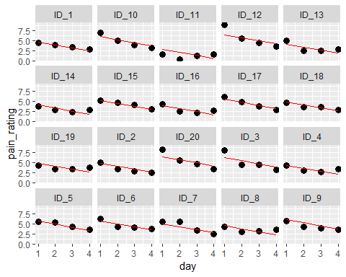
#Random intercept and slope
windows()
ggplot(pain.data.long.withpreds, aes(y = pain_rating, x = day, group = ID))+
geom_point(size = 3)+
geom_line(color='blue', aes(y=pred.slope, x=day))+
facet_wrap( ~ ID, ncol = 5)
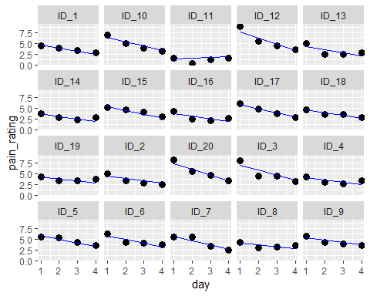
#################
###Comparing AIC
#################
cAIC(model.int)$caic
## [1] 211.6432
cAIC(model.slope)$caic
## [1] 211.6432
#############################
###Compare models in an anova
#############################
anova(model.int, model.slope)
## refitting model(s) with ML (instead of REML)
## Data: pain.data.long
## Models:
## model.int: pain_rating ~ sex + age + weight + STAI_trait + pain_cat + mindfulness +
## model.int: cortisol_serum + day + (1 | ID)
## model.slope: pain_rating ~ sex + age + weight + STAI_trait + pain_cat + mindfulness +
## model.slope: cortisol_serum + day + (day | ID)
## Df AIC BIC logLik deviance Chisq Chi Df Pr(>Chisq)
## model.int 11 217.95 244.16 -97.977 195.95
## model.slope 13 204.93 235.90 -89.466 178.93 17.021 2 0.0002013 ***
## ---
## Signif. codes: 0 '***' 0.001 '**' 0.01 '*' 0.05 '.' 0.1 ' ' 1
###############################################################
###Create a new randome slope model with day as a quadratic term
################################################################
model.slope.quad <- lmer(pain_rating ~ sex + age + weight + STAI_trait + pain_cat + mindfulness + cortisol_serum
+ day + I(day^2) +(day^2|ID), data = pain.data.long)
#####################################################
###GGplot for the new slope model with quadratic term
#####################################################
pain.data.long.withpreds$pred.slope.quad = predict(model.slope.quad)
windows()
ggplot(pain.data.long.withpreds, aes(y = pain_rating, x = day, group = ID))+
geom_point(size = 3)+
geom_line(color='green', aes(y=pred.slope.quad, x=day))+
facet_wrap( ~ ID, ncol = 5)
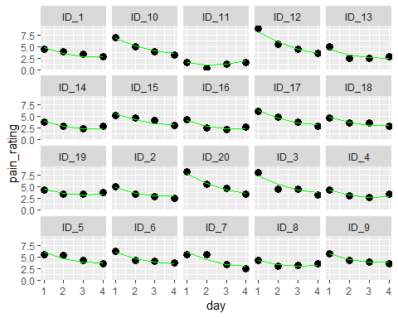
#######################################################################
###Center varible "day" to avoid multicollinearity with the quadtric term
#######################################################################
pain.data.long.centered.day = pain.data.long
pain.data.long.centered.day$day.centered = pain.data.long.centered.day$day -
mean(pain.data.long.centered.day$day)
pain.data.long.centered.day$day.centered.2 = pain.data.long.centered.day$day.centered^2
model.slope.quad <- lmer(pain_rating ~ sex + age + weight + STAI_trait + pain_cat + mindfulness + cortisol_serum
+ day.centered + I(day.centered^2) +(day.centered^2|ID),
data = pain.data.long.centered.day)
####################################
###Checking for influencial outliers
####################################
influence.observation = influence(model.slope.quad, obs = T)$alt.fixed
influence.group = influence(model.slope.quad, group = "ID")$alt.fixed
##Box plots ( Big plots that requires big margins )
pred.names = colnames(influence.group)
#Boxplots too large to be compiled, uncomment and run in r-studio
#par(mfrow=c(1, length(pred.names)))
#for(i in 1:length(pred.names)){
# boxplot(influence.observation[,pred.names[i]], main = pred.names[i])
#}
#for(i in 1:length(pred.names)){
# boxplot(influence.group[,pred.names[i]], main = pred.names[i])
#}
#par(mfrow=c(1,1))
###########################################################
###Checking slopde model with quadratic term for assumptions
###########################################################
#Normality
qqmath(model.slope.quad, id=0.05)
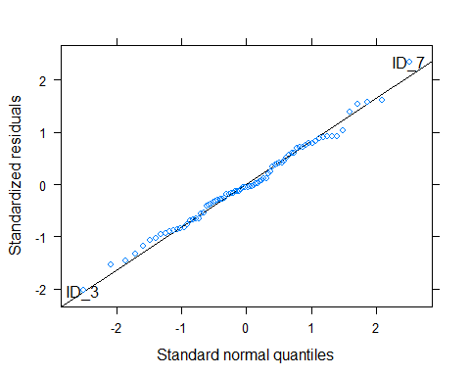
##Linearity
plot(model.slope.quad, arg = "pearson")
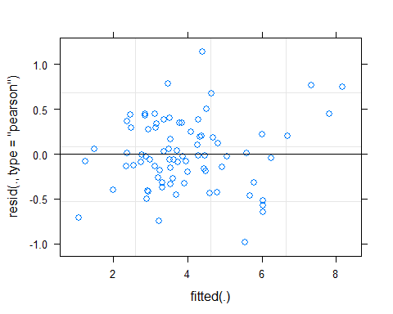
#Residuals linearity
pain.data.long.with.resid = pain.data.long.centered.day
pain.data.long.with.resid$resid = residuals(model.slope.quad)
windows()
plot(resid ~ day.centered, data = pain.data.long.with.resid)
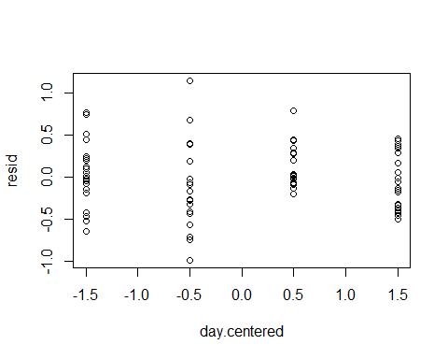
plot(resid ~ day.centered.2, data = pain.data.long.with.resid)
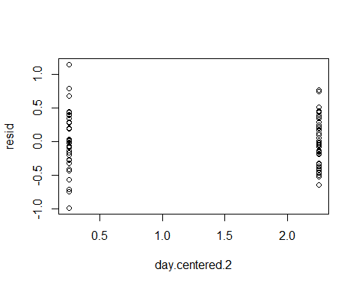
plot(resid ~ sex, data = pain.data.long.with.resid)
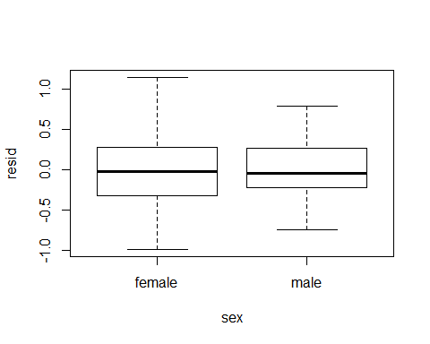
plot(resid ~ age, data = pain.data.long.with.resid)
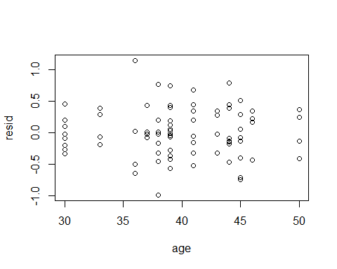
plot(resid ~ pain_cat, data = pain.data.long.with.resid)
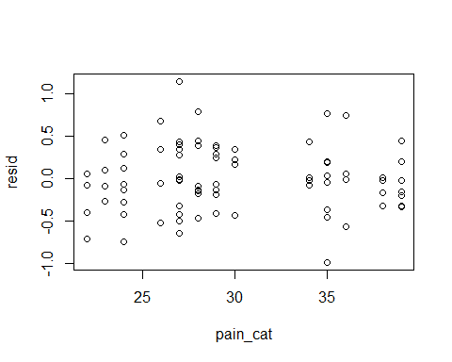
plot(resid ~ STAI_trait, data = pain.data.long.with.resid)
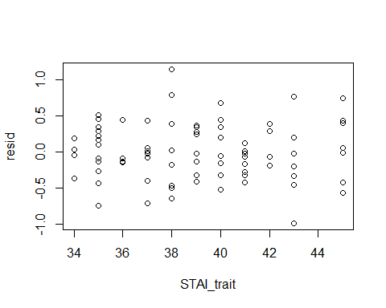
plot(resid ~ mindfulness, data = pain.data.long.with.resid)
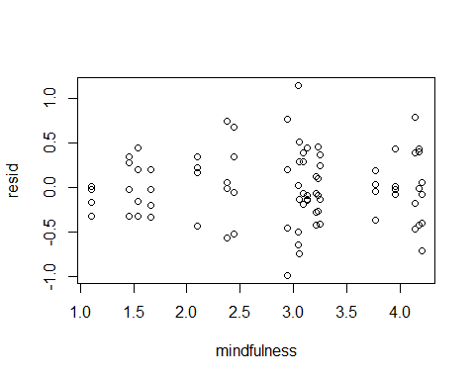
plot(resid ~ cortisol_serum, data = pain.data.long.with.resid)
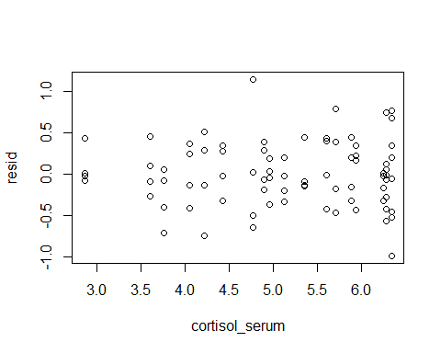
plot(resid ~ weight, data = pain.data.long.with.resid)
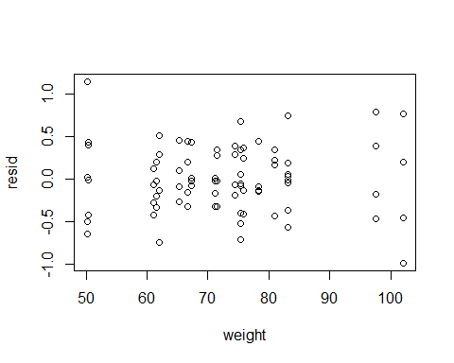
#Homescedacity
homosced.mod = lm(pain.data.long.with.resid$resid^2 ~ pain.data.long.with.resid$ID)
summary(homosced.mod)
##
## Call:
## lm(formula = pain.data.long.with.resid$resid^2 ~ pain.data.long.with.resid$ID)
##
## Residuals:
## Min 1Q Median 3Q Max
## -0.49311 -0.06466 -0.03233 0.06164 0.81822
##
## Coefficients:
## Estimate Std. Error t value Pr(>|t|)
## (Intercept) 0.13184 0.10399 1.268 0.2098
## pain.data.long.with.resid$IDID_10 -0.08321 0.14707 -0.566 0.5737
## pain.data.long.with.resid$IDID_11 0.03822 0.14707 0.260 0.7959
## pain.data.long.with.resid$IDID_12 0.08963 0.14707 0.609 0.5445
## pain.data.long.with.resid$IDID_13 0.09648 0.14707 0.656 0.5143
## pain.data.long.with.resid$IDID_14 -0.08303 0.14707 -0.565 0.5745
## pain.data.long.with.resid$IDID_15 0.12220 0.14707 0.831 0.4093
## pain.data.long.with.resid$IDID_16 -0.03564 0.14707 -0.242 0.8094
## pain.data.long.with.resid$IDID_17 -0.08765 0.14707 -0.596 0.5535
## pain.data.long.with.resid$IDID_18 -0.06956 0.14707 -0.473 0.6380
## pain.data.long.with.resid$IDID_19 -0.06322 0.14707 -0.430 0.6688
## pain.data.long.with.resid$IDID_2 -0.06381 0.14707 -0.434 0.6659
## pain.data.long.with.resid$IDID_20 -0.04075 0.14707 -0.277 0.7827
## pain.data.long.with.resid$IDID_3 0.32304 0.14707 2.196 0.0319 *
## pain.data.long.with.resid$IDID_4 -0.05930 0.14707 -0.403 0.6882
## pain.data.long.with.resid$IDID_5 0.08211 0.14707 0.558 0.5787
## pain.data.long.with.resid$IDID_6 -0.03421 0.14707 -0.233 0.8168
## pain.data.long.with.resid$IDID_7 0.36186 0.14707 2.460 0.0168 *
## pain.data.long.with.resid$IDID_8 -0.05793 0.14707 -0.394 0.6951
## pain.data.long.with.resid$IDID_9 -0.09802 0.14707 -0.666 0.5077
## ---
## Signif. codes: 0 '***' 0.001 '**' 0.01 '*' 0.05 '.' 0.1 ' ' 1
##
## Residual standard error: 0.208 on 60 degrees of freedom
## Multiple R-squared: 0.3338, Adjusted R-squared: 0.1228
## F-statistic: 1.582 on 19 and 60 DF, p-value: 0.09115
# caluclate interquartile range within each cluster
IQR.of.residuals.by.participant = sapply(split(pain.data.long.with.resid, f = pain.data.long.with.resid$ID), function(x) IQR(x$resid))
# rank ordering them
rank = rank(IQR.of.residuals.by.participant)
# adding rank to the dataframe containing the residuals
pain.data.long.with.resid$rank = rep(rank, each = length(repeated.variables))
# creating a vector of participant IDs ordered based on the rank, this will be used as labels
IDforplot = unique(pain.data.long.with.resid$ID[order(pain.data.long.with.resid$rank)])
# create the cyclone plot
ggplot(pain.data.long.with.resid, aes(y = resid, x = factor(rank), labels = ID))+
geom_boxplot()+
scale_x_discrete(labels=IDforplot)+
coord_flip()
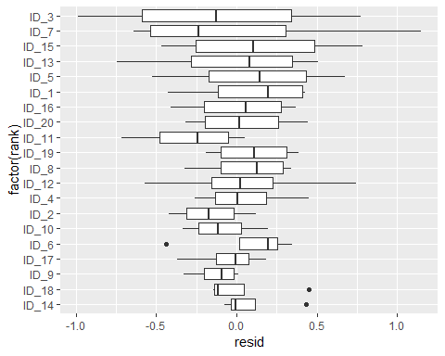
#Multicollinearity
pairs.panels(pain.data.long.centered.day[ ,c("sex", "age", "STAI_trait","pain_cat",
"mindfulness", "cortisol_serum", "weight",
"day.centered", "day.centered.2")], col = "red", lm = T)
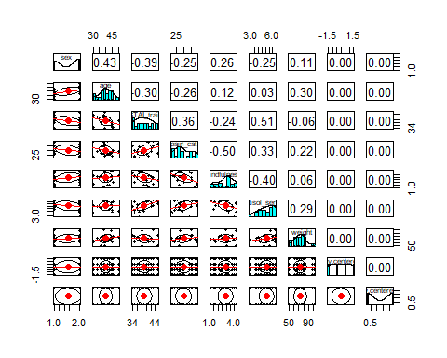
#############################################################
###Table coefficients randome slope model with quadratic term
#############################################################
# Marginal R squared
r2beta(model.slope.quad, method = "nsj", data = pain.data.long.centered.day)
## Effect Rsq upper.CL lower.CL
## 1 Model 0.553 0.685 0.448
## 9 day.centered 0.449 0.588 0.305
## 10 I(day.centered^2) 0.092 0.237 0.009
## 8 cortisol_serum 0.061 0.194 0.002
## 3 age 0.022 0.125 0.000
## 7 mindfulness 0.017 0.115 0.000
## 4 weight 0.012 0.103 0.000
## 5 STAI_trait 0.009 0.093 0.000
## 6 pain_cat 0.008 0.091 0.000
## 2 sexmale 0.004 0.077 0.000
# Conditional AIC
cAIC(model.slope.quad)
## $loglikelihood
## [1] -41.03511
##
## $df
## [1] 33.71481
##
## $reducedModel
## NULL
##
## $new
## [1] FALSE
##
## $caic
## [1] 149.4998
##
## attr(,"class")
## [1] "cAIC"
# Model coefficients
summary(model.slope.quad)
## Linear mixed model fit by REML ['lmerMod']
## Formula:
## pain_rating ~ sex + age + weight + STAI_trait + pain_cat + mindfulness +
## cortisol_serum + day.centered + I(day.centered^2) + (day.centered^2 |
## ID)
## Data: pain.data.long.centered.day
##
## REML criterion at convergence: 196.7
##
## Scaled residuals:
## Min 1Q Median 3Q Max
## -2.03226 -0.54622 -0.05052 0.56609 2.35192
##
## Random effects:
## Groups Name Variance Std.Dev. Corr
## ID (Intercept) 0.3980 0.6309
## day.centered 0.1843 0.4293 -0.92
## Residual 0.2372 0.4870
## Number of obs: 80, groups: ID, 20
##
## Fixed effects:
## Estimate Std. Error t value
## (Intercept) 3.873513 1.884645 2.055
## sexmale -0.133833 0.231672 -0.578
## age -0.033446 0.023624 -1.416
## weight 0.009798 0.009213 1.063
## STAI_trait -0.035078 0.039423 -0.890
## pain_cat 0.020716 0.024306 0.852
## mindfulness -0.171226 0.135895 -1.260
## cortisol_serum 0.321190 0.132082 2.432
## day.centered -0.746968 0.107632 -6.940
## I(day.centered^2) 0.294392 0.054449 5.407
##
## Correlation of Fixed Effects:
## (Intr) sexmal age weight STAI_t pan_ct mndfln crtsl_ dy.cnt
## sexmale -0.037
## age -0.568 -0.347
## weight -0.062 -0.013 -0.270
## STAI_trait -0.680 0.173 0.156 0.232
## pain_cat -0.308 -0.018 0.262 -0.385 -0.241
## mindfulness -0.306 -0.117 0.086 -0.324 -0.171 0.485
## cortisl_srm 0.156 0.104 -0.163 -0.362 -0.506 0.070 0.359
## day.centerd -0.061 0.000 0.000 0.000 0.000 0.000 0.000 0.000
## I(dy.cnt^2) -0.036 0.000 0.000 0.000 0.000 0.000 0.000 0.000 0.000
oldw <- getOption("warn")
options(warn = -1) #Ignores warning message about on identical value
# Confidence intervals for the coefficients
confint(model.slope.quad)
## Computing profile confidence intervals ...
## 2.5 % 97.5 %
## .sig01 0.329311786 0.891267005
## .sig02 -1.000000000 -0.683587163
## .sig03 0.283538164 0.628931603
## .sigma 0.391600819 0.580498172
## (Intercept) 0.659325446 7.074220863
## sexmale -0.519210058 0.252342324
## age -0.071845664 0.004953191
## weight -0.005216666 0.024811435
## STAI_trait -0.098746283 0.028589129
## pain_cat -0.026632329 0.069863610
## mindfulness -0.392271101 0.049819468
## cortisol_serum 0.071213470 0.578952114
## day.centered -0.963404587 -0.530531079
## I(day.centered^2) 0.188412282 0.400371037
options(warn = oldw) #Restores settings for warning messages
# standardized Betas
stdCoef.merMod(model.slope.quad)
## stdcoef stdse
## (Intercept) 0.00000000 0.00000000
## sexmale -0.04536448 0.07852831
## age -0.11558821 0.08164401
## weight 0.08596762 0.08083942
## STAI_trait -0.07828081 0.08797698
## pain_cat 0.07508647 0.08809917
## mindfulness -0.10770403 0.08547989
## cortisol_serum 0.22312057 0.09175328
## day.centered -0.56901324 0.08199024
## I(day.centered^2) 0.20058154 0.03709820

